agInnovation Budget and Legislative Committee Recommendations Brief for the FY2028 Hatch Act Appropriations
DRAFT Recommendation
The Budget and Legislative Committee (BLC) recommends that agInnovation support a FY2028 Hatch Act appropriation request of $357 million (or we can round up to $360—easier messaging ) to restore the purchasing power and research capacity supported by prior congressional investments.
This recommendation is based solely on inflationary adjustments and does not account for expanded research demands, increased operational costs, workforce pressures, deferred infrastructure needs, or emerging national priorities. As such, the recommended funding level should be viewed as a capacity restoration request rather than an expansionary investment.
Background
The Hatch Act remains one of the federal government's most effective and enduring investments in agricultural research. Hatch funding provides the foundational capacity that supports the nation's State Agricultural Experiment Stations (SAES) and Land-grant Universities, enabling institutions to conduct long-term, locally relevant, multistate, and rapid-response research.
Hatch-supported research contributes directly to:
- Food and nutritional security;
- Agricultural productivity and global competitiveness;
- Natural resource stewardship;
- Public health and food safety;
- Rural economic vitality;
- National security and supply chain resilience; and
- Responses to emerging pests, diseases, invasive species, and weather-related threats.
Unlike competitive grant programs, Hatch funding provides the stable infrastructure, scientific expertise, facilities, and partnerships* necessary to address both immediate and long-term agricultural challenges.
*APLU capacity initiative has nice data demonstrating the important partnerships LGUs have with industry that may be impactful in our messaging.
Erosion of Research Capacity
Despite growing demands on the U.S. agricultural research enterprise, Hatch Act appropriations have remained largely stagnant when adjusted for inflation (figures 1 and 2).
Between FY2016 and FY2026:
FY2016 Hatch Appropriation | $244 million
Estimated FY2026 Appropriation | $265 million
Increase in Appropriation over 10 years | $21 million (+8.6%)
Estimated FY2028 Inflation-Adjusted Need | $357 million
Increase Needed to Maintain Purchasing Power (this does not take into consideration $21 M increase) | $113 million (+46.3%)
FY2028 Funding Gap | $92 million
Purchasing Power Retained | 74.2%
Purchasing Power Lost | 25.8%
Increase Needed Above Current Funding | 25.8%
While Hatch appropriations increased by only $21 million since FY2016, inflation increased the cost of conducting research by approximately $113 million. As a result, the annual gap between actual funding and the funding necessary to maintain research capacity has grown to approximately $92 million.
By FY2028 and if funding remains flat, Hatch funding will support only about 74 percent of the purchasing power and research capacity supported by the FY2016 appropriation. More than one-quarter of Hatch-supported research capacity has effectively been lost to inflation.

Figure 1. Hatch Act Appropriations Have not Kept Pace with Inflation
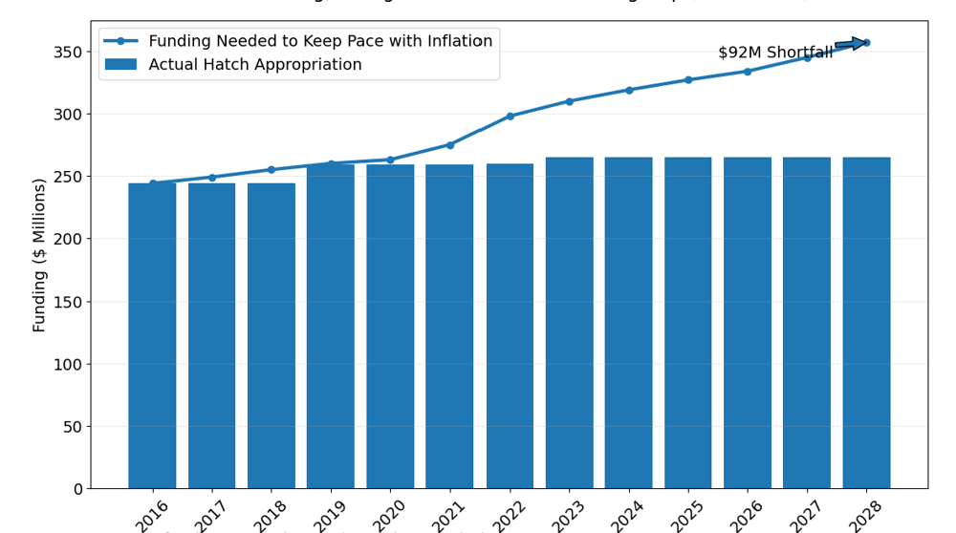

Figure 2. Research Capacity Erosion since 2016
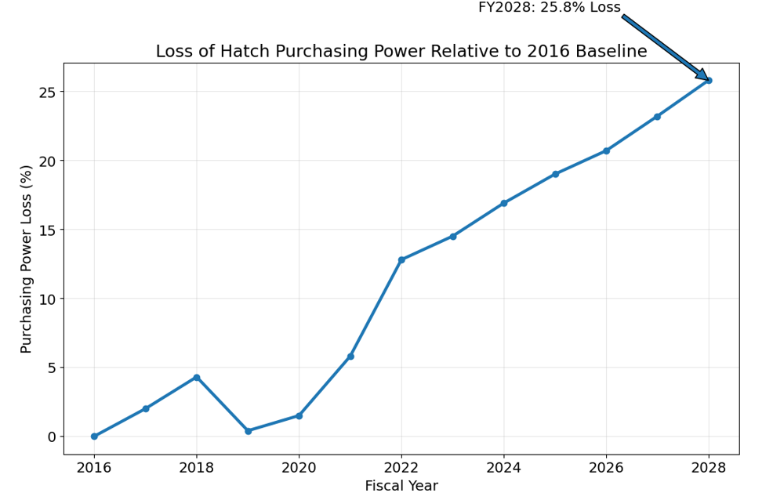

Why This Matters
The erosion of Hatch purchasing power has tangible consequences for the nation's agricultural research enterprise.
Reduced Scientific Expertise and Research Capacity
- Reduced purchasing power limits institutions' ability to recruit and retain highly specialized scientific expertise in critical fields such as:
- Plant breeding and genetics;
- Animal health, breeding, and production;
- Soil health and nutrient management;
- Environmental sustainability;
- Water quality and water quantity;
- Precision agriculture and artificial intelligence;
- Biosecurity, food safety and food systems;
- Human nutrition/nutritional security and health;
- Climate resilience and adaptation;
- Agricultural economics and rural development.
Once expertise is lost through retirements, hiring freezes, or eliminated positions, rebuilding that capacity often requires years or even decades.
Research Programs
Declining real-dollar support increasingly forces institutions to reduce or eliminate research programs that are not easily supported through short-term competitive grants.
Examples may include:
- Long-term soil health studies;
- Plant breeding programs requiring multi-year selection cycles;
- Water quality monitoring networks;
- Integrated pest management programs;
- Crop and livestock systems research;
- Regional and multistate research collaborations.
Many of these programs generate benefits over decades rather than grant cycles and therefore depend heavily on stable capacity funding. These investments produce the discoveries, innovations, and practical solutions needed to address critical agricultural, environmental, economic, and food system challenges across local, state, regional, and national levels.

Graduate Student and Workforce Development (can we pull together data to demonstrate loss and need?)
Hatch funding plays a significant role in training the next generation of agricultural scientists and innovators.
Reduced purchasing power results in:
- Fewer graduate research assistantships;
- Reduced undergraduate research opportunities;
- Fewer postdoctoral research positions;
- Reduced scientific workforce development capacity in high-demand agricultural disciplines.
Research Infrastructure and Facilities
Inflationary pressures also affect the operation and maintenance of research farms, laboratories, field stations, and specialized research facilities. As resources are redirected toward fixed operating costs, fewer dollars remain available for research activities and innovation.
Economic Impact of Restoring Purchasing Power
Agricultural research consistently generates among the highest returns of any federal investment.
Studies have estimated public returns on agricultural research investments ranging from $10 to more than $20 for every $1 invested.
Restoring the approximately $92 million annual Hatch funding gap would:
- Strengthen national agricultural productivity;
- Accelerate innovation and technology development and adoption;
- Improve producer profitability;
- Support food security and affordability;
- Enhance environmental sustainability;
- Strengthen agricultural and national security;
- Strengthen rural economies; and
- Maintain U.S. leadership in agricultural science and innovation.
Using commonly cited agricultural research return estimates, restoring the $92 million gap could ultimately generate billions of dollars in long-term economic benefits.

agInnovation BLC Recommendation for FY2028 Hatch Act Appropriation:
The BLC recommends a FY2028 Hatch Act appropriation of $357 million, or an increase of at least $92 million over FY2026 estimated appropriations level, to restore the purchasing power and research capacity Congress previously supported.
This recommendation is not based on program expansion. Rather, it reflects the funding necessary to preserve the scientific capacity, expertise, infrastructure, and innovation system that underpin the nation's agricultural research enterprise.
Maintaining the strength and responsiveness of the U.S. agricultural research system requires federal investment that keeps pace with economic realities and ensures Land-grant Universities can continue delivering science-based solutions that benefit producers, consumers, communities, and the nation.

Alternative Approach
An alternative approach would be to recommend a FY2028 Hatch Act appropriation increase of $120 million, which is approximately equivalent to $500,000 per 1862 Land-grant University. USDA ARS frequently uses a similar funding level when requesting support for a new scientist position, making this a useful benchmark for communicating the scale of investment.
This approach recognizes that Congress rarely provides the full amount requested. By establishing a $120 million funding target, the request not only addresses the documented inflationary shortfall but also reflects the increasing demands placed on the agricultural research enterprise, including advancements in artificial intelligence, precision agriculture, automation and robotics, genomics and gene editing, digital agriculture, climate resilience, biosecurity, and other emerging priorities.
From a strategic appropriations perspective, a $120 million request may improve the likelihood of securing an appropriation closer to the $92 million inflation-adjusted need while also providing a strong policy rationale and messaging for investing in the future capacity and competitiveness of U.S. agriculture. This framing positions the request not simply as a restoration of lost purchasing power, but as a targeted investment in maintaining America's leadership in agricultural innovation and ensuring the research enterprise is equipped to address future challenges and opportunities.

Data and Supporting Evidence to Strengthen the FY2028 Hatch Act Request**
To further strengthen the justification for an increased Hatch Act appropriation, we should build upon the analyses developed by Anton in previous appropriations requests and update the supporting data and impact narratives.
Loss of Scientific Expertise and Capacity (presented to BAC for FY2026 request)
- Update Anton’s estimates of the decline in Hatch-supported scientific FTEs; however, rather than focusing solely on personnel numbers, frame the analysis around the loss of scientific expertise and institutional capacity.
- Identify specific disciplines and areas of expertise that have been reduced or eliminated due to funding constraints, such as plant breeding, soil health, water resources, animal health, food systems, agricultural economics, integrated pest management, and emerging technology fields.
- Quantify the extent to which institutions have been unable to replace retiring faculty and researchers or invest in new areas of scientific opportunity.
Loss of Research Programs and Innovation Capacity (also presented to BAC for FY2026 request)
- Update Anton’s estimates of Hatch-supported research programs that have been reduced, consolidated, or discontinued as purchasing power has declined.
- Identify specific examples of long-term research efforts, monitoring networks, breeding programs, multistate collaborations, or applied research initiatives that have been curtailed due to limited resources.
- Develop compelling impact stories that illustrate how the loss of these programs has affected producers, rural communities, industry partners, natural resource management, or the ability to respond to emerging challenges.
Impact on Workforce Development and the Next Generation of Scientists
- Can we assess the impact of declining Hatch purchasing power on graduate and undergraduate student training opportunities?
- Quantify reductions in graduate assistantships, undergraduate research experiences, postdoctoral positions, and other workforce development activities supported through Hatch funding.
- Demonstrate how reduced investments today affect the future pipeline of agricultural scientists, researchers, Extension professionals, and industry leaders.
Economic Impact of Restoring Research Capacity
- Estimate the economic benefits associated with restoring Hatch funding to its inflation-adjusted purchasing power.
- Utilize available return-on-investment estimates for agricultural research to quantify the potential economic value generated by closing the current funding gap.
- Highlight how restored research capacity would contribute to agricultural productivity, competitiveness, food security, environmental sustainability, rural economic development, and national resilience.
Collectively, these data and impact narratives would allow us to move beyond discussing inflation and funding levels alone and instead demonstrate the real-world consequences of declining research capacity—and the benefits that could be realized through restoring Hatch funding to an inflation-adjusted level.

**Some of this data may be uncovered by the APLU Capacity Initiative.

